Models of Group Dynamics

Tuckman’s Groups (1965)
As you’re going to be involved in teaching small groups it’s imperative you have some understanding about group dynamics (how groups work). Tuckman’s model helps you understand ‘how groups develop’ thus helping you to help a group function more effectively. By the way, Tuckman’s model can be applied to teams as well as small groups.

According to the model, groups that are going to be in existence for a while (i.e. not ‘one offs’) go through four stages as they come together and start to function. But how long they spend at each stage depends on how well they know each other: if there are lots of familiar faces, less time might be spent on the first three stages and the group quickly progresses to the desired performing stage. But that’s not to belittle the first three stages: it’s important for groups to go through each stage otherwise they might ‘perform’ but not very well. Groups often become dysfunctional (stuck in the storming stage) if the facilitator has not allowed enough time and attention for the forming stage.

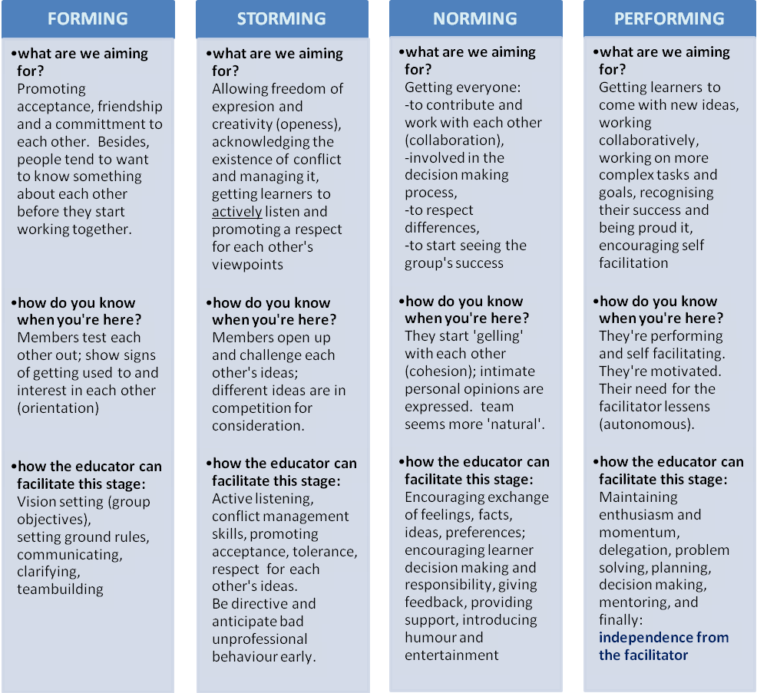
A fifth stage, adjourning (or some call mourning) was added in 1975: ten years later. This is where the group’s life span comes to an end and they split. There may be some feeling of loss amongst members. However, it still doesn’t feature in most visual representations of Tuckman’s model because he wanted to focus on how groups develop, not how they end; it’s the former that is going to help us as facilitators.

How to Use This Model
- Forming is a crucial stage. Members usually know little about the purpose of the group and these needs to be explored. Otherwise, how else are they going to ‘buy in’? They need to see what’s in it for them. Members model behaviour even at this very early stage.
- Storming needs careful facilitation. Individuals challenge each other’s ideas but you need to enable exploration and challenge to happen without the process becoming destructive. How long a group ‘lives’ in this stage depends on the maturity of the individual members. Aiming to get out of this stage ‘as quickly as possible’ is wrong thinking: this stage lays the foundation for ‘norming’. Promote acceptance, tolerance and respect. It is here where groups will resolve differences and learn to truly start ‘working with’ each other. By ‘truly’, we mean being honest, open and participative.
- In Norming individuals are not as rigid in their thinking and adjust their behaviour to what others say or do appropriately. By expressing ‘personal opinions’ they start showing trust in one another. Be careful though: they may start to get used to ‘the group way of thinking’ which will then inhibit creativity.
- In the Performing stage facilitators can take a back seat and almost become participants as the group starts to facilitate itself. Beware: the group might revert back to previous stages and the appropriateness of that depends on a variety of factors such as the task, new members leaving/joining etc; it’s not necessarily a bad thing as long as they progressively move forwards again.

Some Thoughts
- Tuckman’s model is linear: it starts at one end, ends at the other and is sequential in between. Life is just not like that. Therefore, some believe groups can ‘jump’ between stages. At any one time, a group might be more concerned with developing interpersonal relationships (norming) and is more task orientated (performing) at other times – sometimes even during the same session (Bales, 1965). Therefore a group can appear to be in a constant state of flux between the norming and performing stages and other research shows storming waxes and wanes throughout the stages.
- The stages in Tuckman’s model are clear cut. Again, life is not so ‘black and white’. Therefore, it is proposed that there should be overlap between the stages. For instance, the processes happening at the storming stage will at times be helping the group gel together (norming).

Cog’s Ladder (Charrier, 1972)
Cog’s Model is very similar to Tuckman’s model but uses less lavish terminology which some of you will find makes it easier to remember and understand. In addition, Cog’s model is more explicit about separating the ‘polite’ and ‘why we’re here’ stages which together form part of Tuckman’s ‘forming stage’. The ladder goes something like this:
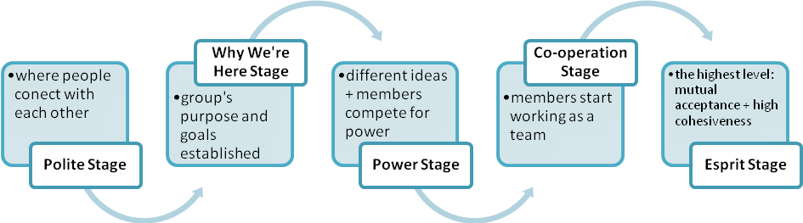
By the way, ‘esprit’ means liveliness of mind or spirit. Some of you may be familiar with the phrase ‘esprit de corps’ which refers to ‘the common spirit of comradeship, enthusiasm, and devotion to a cause amongst members of a group that makes it want to succeed’.

Like we’ve said before, an appreciation and understanding of the way groups or teams usually develop is likely to
- remind us of the stages of normal group development and thus monitor progression
- help us identify key facilitation skills required at each stage
- help us decide how to move each stage along if the group gets a little stuck
- highlight in advance the ‘risky’ stages where things can go badly wrong and detect it early
- help us put in remedial measures to get dysfunctional groups working again.

References
- Tuckman, Bruce W. (1965) 'Developmental sequence in small groups', Psychological Bulletin, 63, 384-399. The article was reprinted in Group Facilitation: A Research and Applications Journal - Number 3, Spring 2001 and is available as a Word document: http://dennislearningcenter.osu.edu/references/GROUP%20DEV%20ARTICLE.doc. accessed 21.2.2009.
- Charrier George: Cog's Ladder: A Model of Group Growth’ by George O. Charrier, an employee of Procter and Gamble, written and published for a newsletter in that company in 1972.

